**An Analysis of Kickstarter Campaigns**

**Purpose of the Analysis**

Our Client, Louise, wants to create a Kickstarter Campaign to fund her new US Based Theatre Play. In order to ensure success with this campaign, she requested an analysis of past Kickstarter Campaigns to determine if there were any trends leading to success. Using data from over 4000 campaigns, the data was filtered, sorted, and statistically analyzed for any findings that might be useful to Louise. This report contains both the analysis as well as Final Recommendations.

**Methodology**

We followed the standard Data Science Methodology shown below with the exception that the original data file (Excel) – which had been previously Extracted from the Kickstarter website API – was provided to us. It was stored locally in Excel format while we did our

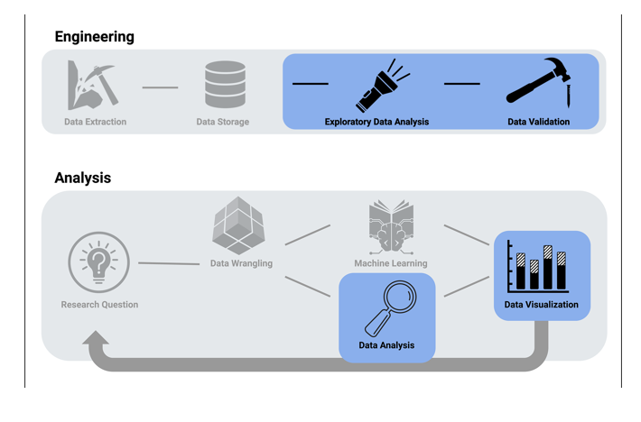

**Exploratory Data Analysis**

As mentioned, the data consisted of over 4000 Kickstarter Campaigns from around the world. The scatter plot below shows that most campaigns had modest fundraising Goals of under $5000, with only a small percentage reaching above $10K.

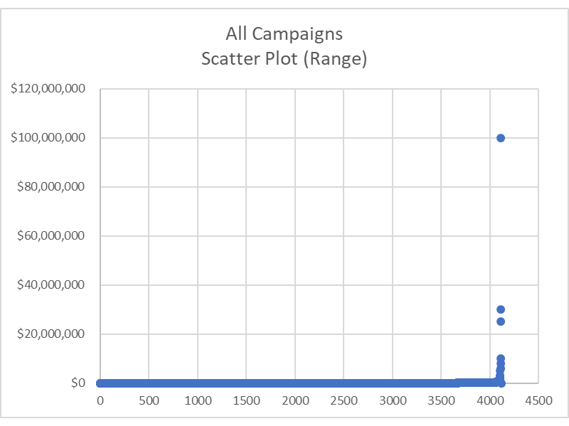

To perform a meaningful analysis for the Client, this indicated that we would most likely need to filter the data down to a more relevant set of data. Filtering by Category and SubCategory of the Campaign, plus Geography, Outcome, and Timing of Launch might yield findings.

Looking at U.S. Only Data across all Categories, we see the following results. At this level of our drill down, the good news for Louise is that the Theater, Music, and Films Categories had the largest number of Successful Campaigns.

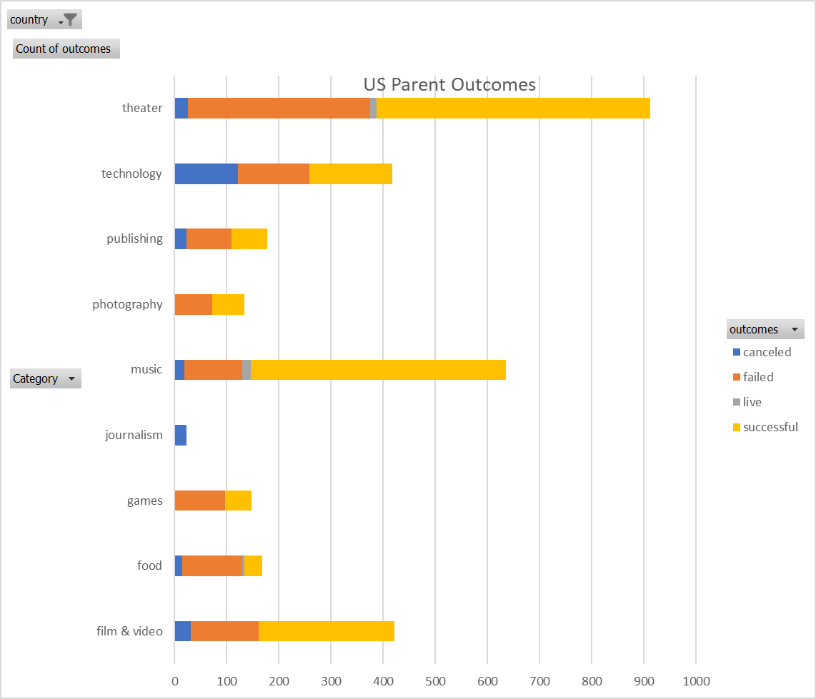

Blah

**Data Validation**

Blah

**Research Questions**

Blah

**Data Wrangling**

There was no need to do a lot of Data Wrangling of the data as it was provided in reasonably complete excel spreadsheet format. Additional columns of calculated data were appended to the data provided for Percent Successful, and also splitting the Category/SubCategory to create 2 new columns to better sort the data.

In addition, 12 Histogram Categories were setup to stratisfy the data by $ Goal and determine its distribution. Further statistical analysis was performed on this data to show Mean, Median, and Std Dev along with IRQ.

**Data Analysis**

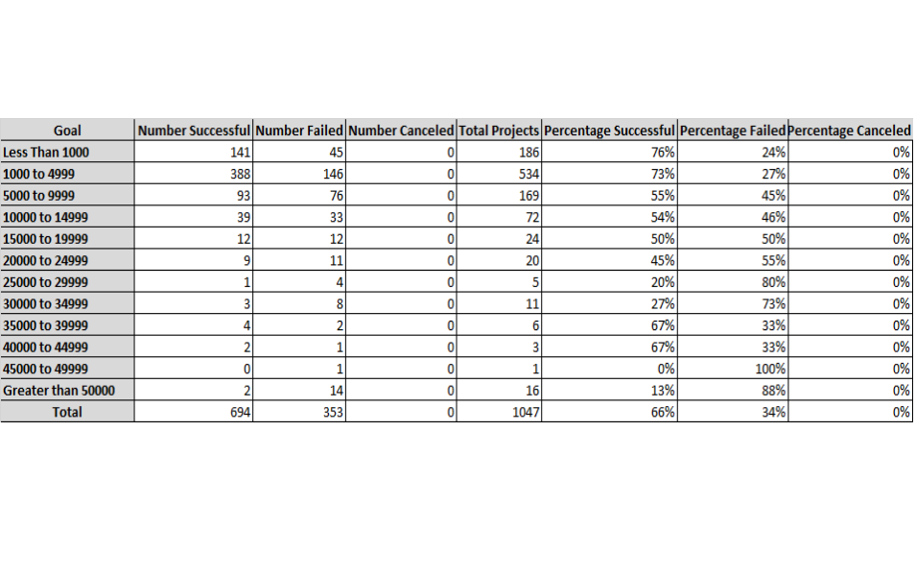

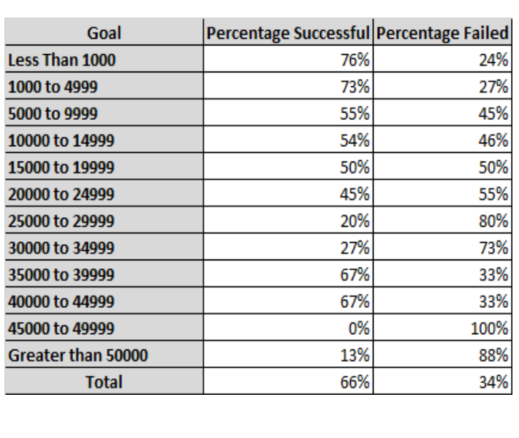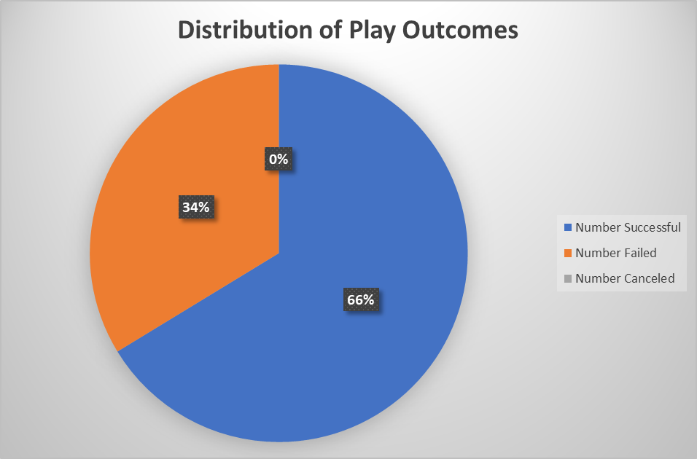

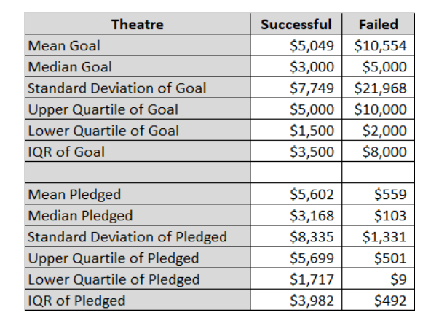

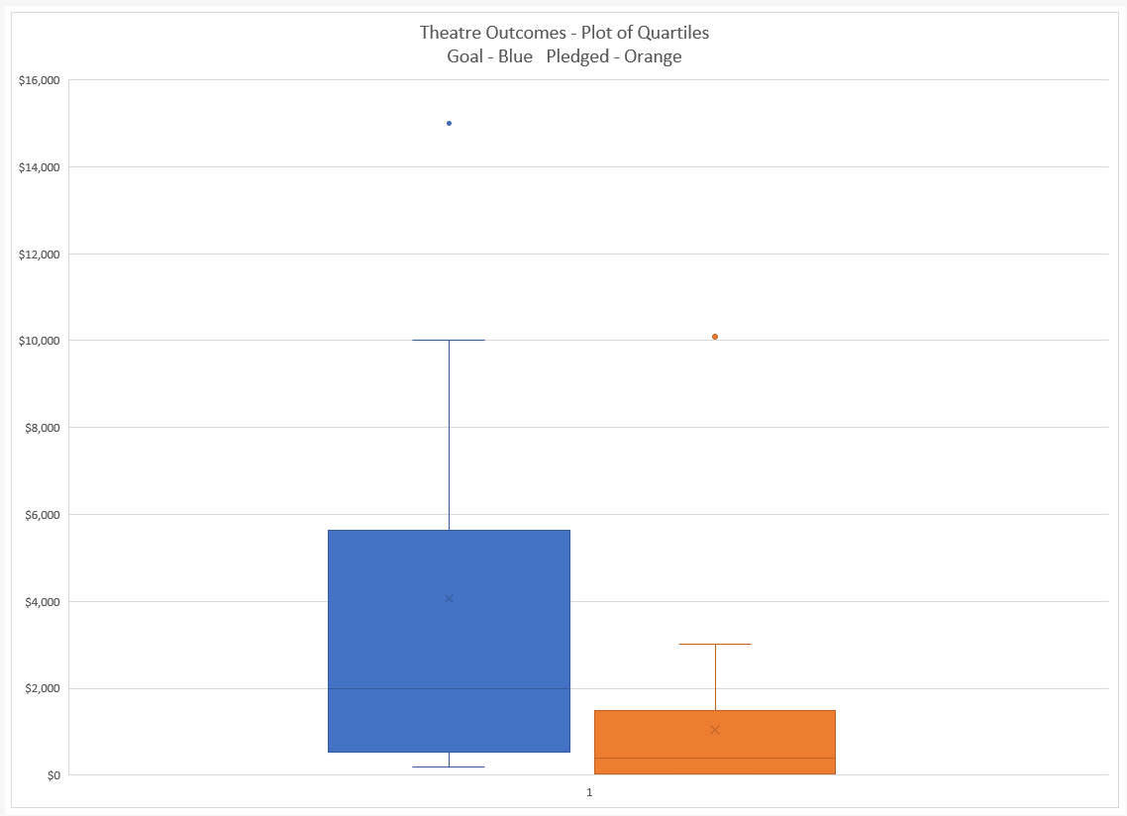

**Final Conclusions**

1. To be successful, individual Theatre Play Campaigns should not exceed $5000. Louise's Proposed Campaign of $20,000 exceeded that threshold significantly, therefore has little chance of success unless the target is lowered.
2. In general, as the Campaign Goal amount increased, Success percentage dropped and Failure Rates increased.
3. There is an anomaly in the data at the $25-35K level. We see that success peaks back up to the 73-80%. This is unexplained and may be for Theatre Building projects, not just Plays.
4. Seasonality affected the success of Theatre Play Campaigns and had the greatest success when launched in the May-June timeframe of each year. Louise might consider launching during this timeframe to increase chances of success.

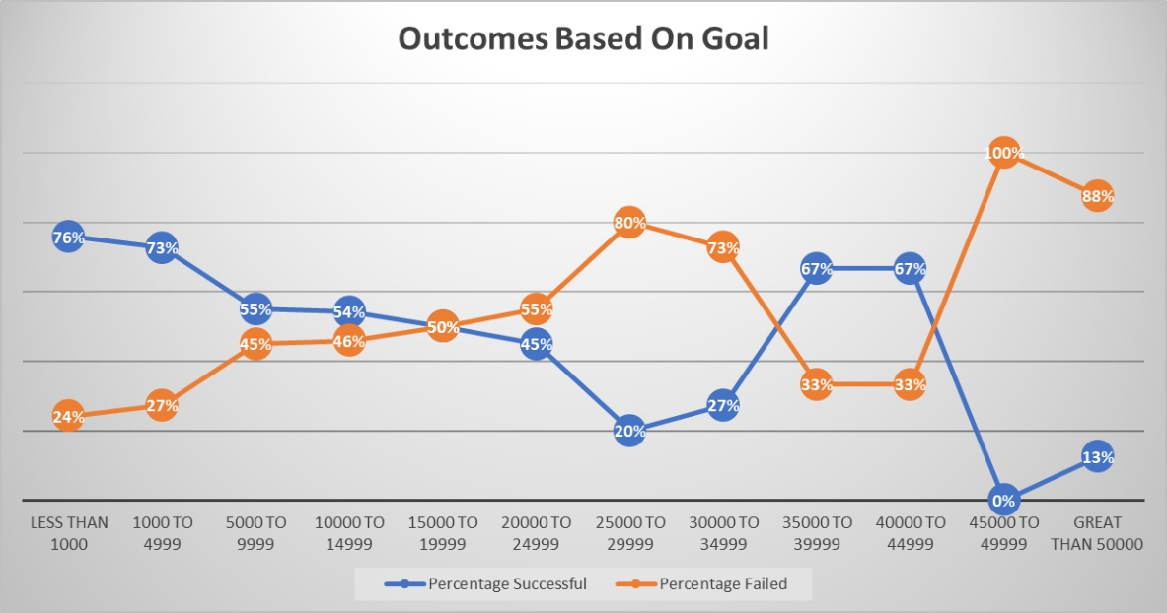

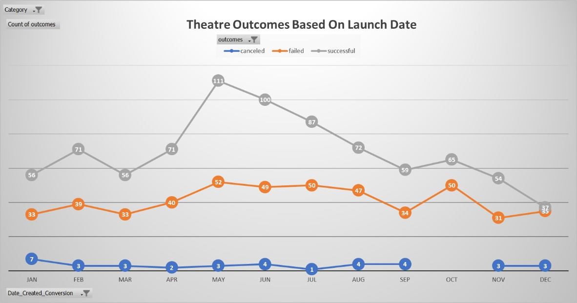

**Edinburgh Research/Additional Recommendations**

The Client was also interested in doing a future project – specially a play for the market in Great Britain. She had 5 specific plays that she was interested in. We pulled the data on those 5 Plays and we pulled data on all GB Play Campaigns in the past – over 300 Campaigns with the results shown below.

1. From the data we can see that in general, GB Plays had a Success Rate of almost twice that of US Based Campaigns. For the 5 specific Plays, goals were kept to $4K.

